Ready Reference  BCH Quick Start | RR01

Register Select a language

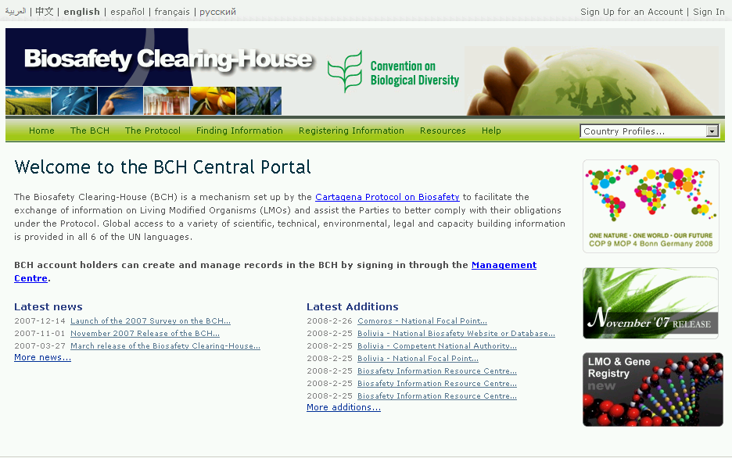
Quick
sSearch
Register a record
Find a record
Help modules

Quick search | Choose a country from the drop-down box to get country profile with all its records,.
Find a record | Choose a category of information and browse the records, or carry out a detailed search (selections will be translated to include records in other languages).
Register a record | Enter the Management Centre to access your account or apply for a new account and create and manage your records in the BCH.
Select a language | Select the name of the language in which you wish to browse the website.
Help modules | Access the BCH tutorials, help manuals, and training modules that explain how to use the website.

